Lab: Implementing NameNode HA

|  |  |
| --- | --- |
| **Objective:** | To configure and verify NameNode High Availability using Ambari. |
| **Successful Outcome:** | Your cluster will have a Standby NameNode along with Active NameNode. |
| **Before You Begin:** | Open the Ambari UI at [localhost]:8080 |

1. Enable NameNode HA
   1. Go to the Admin page and select **High Availability.** Click on Enable NameNode HA button.

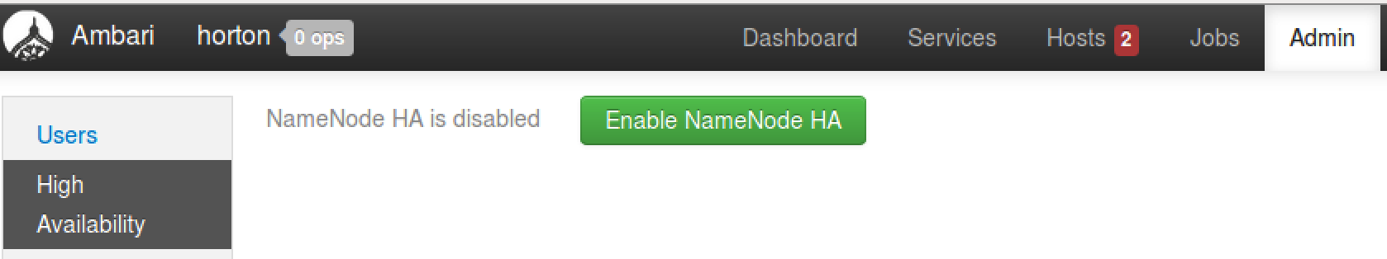

* 1. Enter HACluster as the Nameservice ID for your NameNode HA cluster. (The name must consist of one word and not have any special characters.) Click the Next button:



* 1. Choose node4 as the Additional NameNode:

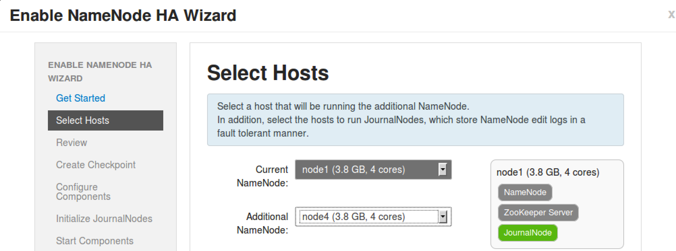

* 1. Click the Next button.
  2. Notice that a Secondary NameNode is not allowed if you have NameNode HA configured. Ambari takes care of this for you, as you can see on the Review step of the wizard:

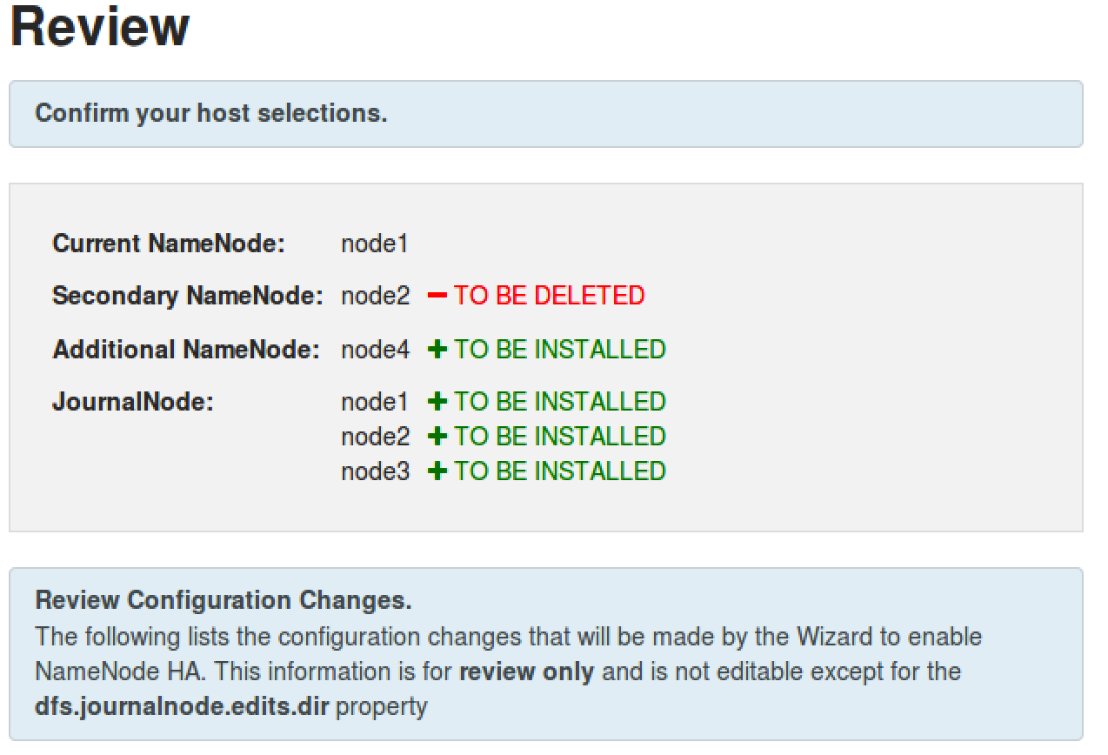

* 1. Review changes in the configuration and click the Next button to continue the wizard.

1. Perform the Manual Steps
   1. Notice the Enable NameNode HA Wizard is requiring you to perform some manual steps before you are able to continue.
   2. Start by SSH-ing into node1.
   3. Put the NameNode in Safe Mode:

# sudo su -l hdfs -c 'hdfs dfsadmin -safemode enter'

* 1. Create a Checkpoint:

# sudo su -l hdfs -c 'hdfs dfsadmin -saveNamespace'

* 1. Once Ambari recognizes that your cluster is in Safe Mode and a Checkpoint has been made, you will be able to click the Next button.

1. Wait for the Configuration
   1. At this point, Ambari will stop all services, install the necessary components, and restart the services. Wait for these tasks to complete:

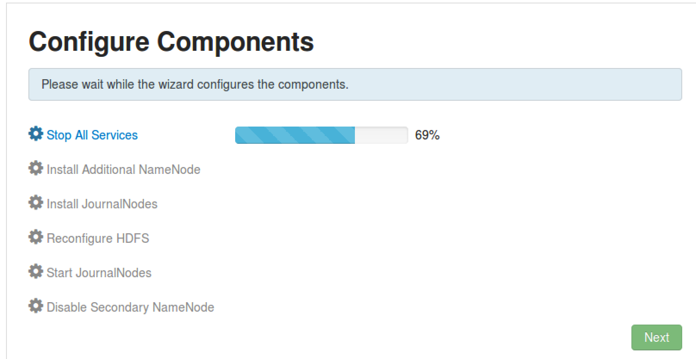

* 1. Once all the tasks are complete, click the Next button.

1. Initialize the JournalNodes
   1. On node1, enter the command shown in the wizard to initialize the JournalNodes:

# sudo su -l hdfs -c 'hdfs namenode -initializeSharedEdits'

* 1. Once Ambari determines that the JournalNodes are initialized, you will be able to click the Next button:

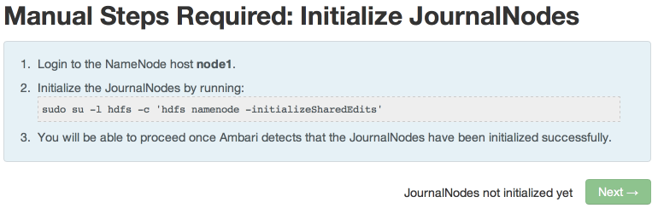

1. Start the Components
   1. In the next step, Ambari will start ZooKeeper and the NameNode service. Click Next when its complete:

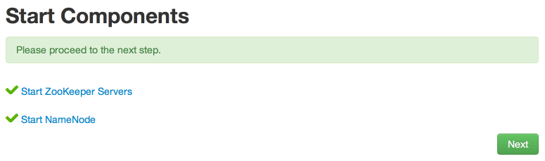

1. Initialize NameNode HA Metadata
   1. On node1, enter the command shown in the wizard to configure the metadata for automatic failover:

# sudo su -l hdfs -c 'hdfs zkfc -formatZK'

* 1. On node4, run the command to initialize the metadata for the new NameNode:

# sudo su -l hdfs -c 'hdfs namenode -bootstrapStandby'

* 1. Click the Next button to continue.

1. Wait for the Wizard to Finish
   1. In this final step, the wizard will start all required services and delete the Secondary NameNode:

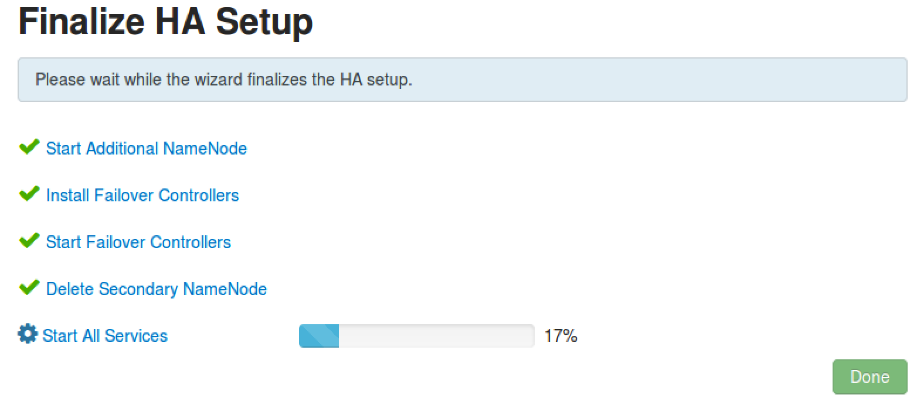

* 1. Click the Done button when all the tasks are complete.

1. Verify the Standby NameNode
   1. Go to the HDFS service page. You should see an Active NameNode and a Standby NameNode:



1. Test NameNode HA.
   1. Go the Host page of node1 in Ambari.
   2. Next to the Active NameNode component, select Stop from the Action menu:

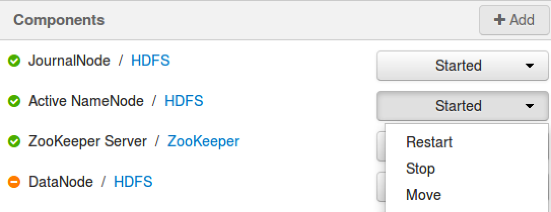

* 1. Go back the HDFS page in Ambari. Notice the Standby NameNode has become the Active NameNode:



* 1. Now start the stopped NameNode again, and you will notice that it becomes a Standby NameNode:



**RESULT**: You now have NameNode HA configured on your cluster, and you have also verified that the HA works when one of the NameNodes stops.